STIEBER CSK, CSK-2RS
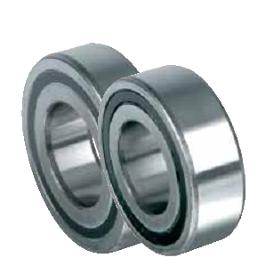
  Применение:
  CSK8 | CSK12 | CSK15 | CSK17 | CSK20 | CSK25 | CSK30 | CSK35 | CSK40
  CSK8 2RS | CSK12 2RS | CSK15 2RS | CSK17 2RS | CSK20 2RS | CSK25 2RS | CSK30 2RS | CSK35 2RS | CSK402RS

STIEBER CSK..P, CSK..PP, CSK..P-2RS
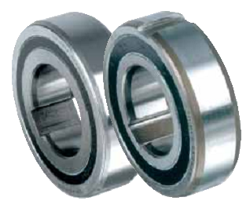
  Применение:
  CSK12P | CSK15P | CSK17P | CSK20P | CSK25P | CSK30P | CSK35P | CSK40P
  CSK12PP | CSK15PP | CSK17PP | CSK20PP | CSK25PP | CSK30PP | CSK35PP | CSK40PP
  CSK12P-2RS | CSK15P-2RS | CSK17P-2RS | CSK20P-2RS | CSK25P-2RS | CSK30P-2RS | CSK35-2RS | CSK40P-2RS

STIEBER ASK
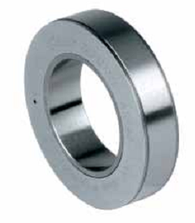
  Применение:
  ASK40 | ASK40 | ASK40

STIEBER GFK
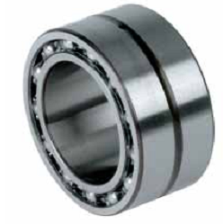
  Применение:
  GFK20 | GFK25 | GFK30 | GFK35 | GFK40 | GFK45 | GFK50

STIEBER KI
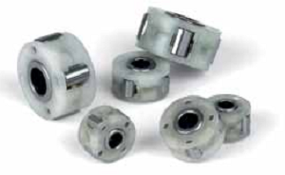
  Применение:
  KI164 | KI165 | KI194 | KI195 | KI196 | KI268 | KI269 | KI2610

STIEBER AS
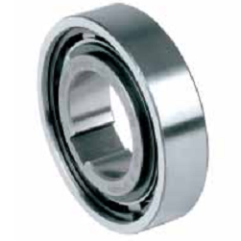
  Применение:
  AS6 | AS8 | AS10 | AS12 | AS15 | AS20 | AS25 | AS30 | AS35 | AS40 | AS45 | AS50 | AS55 | AS60 | AS80
  NSS6 | NSS8 | NSS10 | NSS12 | NSS15 | NSS20 | NSS25 | NSS30 | NSS35 | NSS40 | NSS45 | NSS50 | NSS55 | NSS60 | NSS80

STIEBER ASNU
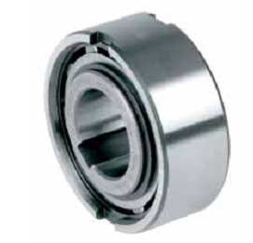
  Применение:
  ASNU8 | ASNU10 | ASNU12 | ASNU15 | ASNU20 | ASNU25 | ASNU30 | ASNU35 | ASNU40 | ASNU45
  ASNU50 | ASNU55 | ASNU60 | ASNU70 | ASNU80 | ASNU90 | ASNU100 | ASNU120 | ASNU150 | ASNU200

STIEBER AE
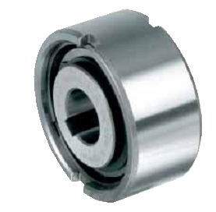
  Применение:
  AE12 | AE15 | AE20 | AE25 | AE30 | AE35
  AE40 | AE45 | AE50 | AE55 | AE60 | AE70

STIEBER AA
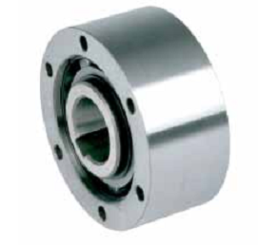
  Применение:
  AA12 | AA15 | AA20 | AA25 | AA30 | AA35
  AA40 | AA45 | AA50 | AA55 | AA60 | AA70

STIEBER NF
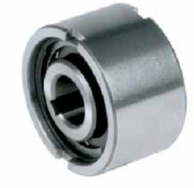
  Применение:
  NF8 | NF10 | NF12 | NF15 | NF20 | NF25 | NF30 | NF35 | NF40 | NF45
  NF50 | NF55 | NF60 | NF70 | NF80 | NF90 | NF100 | NF130 | NF150

STIEBER S200
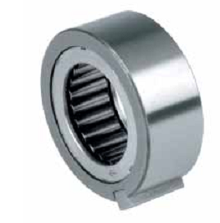
  Применение:
  S203 | S204 | S205 | S206 | S207 | S208 | S209 | S210

STIEBER DC
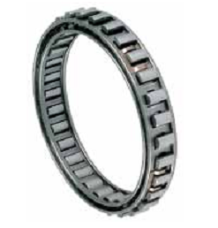
  Применение:
  DC

STIEBER NFR
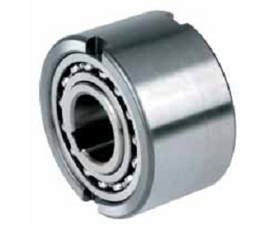
  Применение:
  NFR8 | NFR10 | NFR12 | NFR15 | NFR20 | NFR25 | NFR30 | NFR35 | NFR40
  NFR45 | NFR50 | NFR55 | NFR60 | NFR70 | NFR80 | NFR90 | NFR100 | NFR130

STIEBER DC
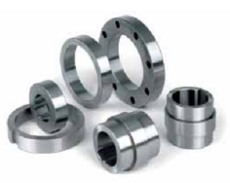
  Применение:
  DC-races

STIEBER RSBW
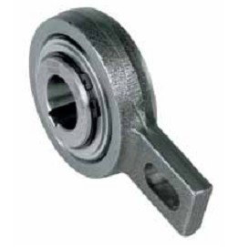
  Применение:
  RSBW20 | RSBW25 | RSBW30 | RSBW35 | RSBW40 | RSBW45
  RSBW50 | RSBW55 | RSBW60 | RSBW70 | RSBW80 | RSBW90

STIEBER AV
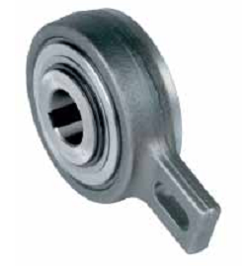
  Применение:
  AV20 | AV25 | AV30 | AV35 | AV40 | AV45 | AV50 | AV55
  AV60 | AV70 | AV80 | AV90 | AV100 | AV110 | AV120

STIEBER AL / STIEBER ALP / STIEBER ALM
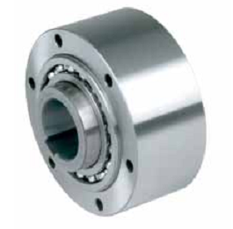
  Применение:
  AL12 | AL15 | AL20 | AL25 | AL30 | AL35 | AL40 | AL45 | AL50 | AL55
  AL60 | AL70 | AL80 | AL90 | AL100 | AL120 | AL150 | AL200 | AL250
  ALP12 | ALP15 | ALP20 | ALP25 | ALP30 | ALP35 | ALP40 | ALP45 | ALP50 | ALP55
  ALP60 | ALP70 | ALP80 | ALP90 | ALP100 | ALP120 | ALP150 | ALP200 | ALP250
   |  |  | ALM25 | ALM30 | ALM35

STIEBER AL..F2D2 / STIEBER AL..F4D2 / STIEBER ALM..F2D2 / ALM..F4D2
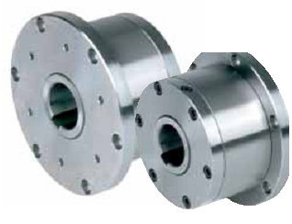
  Применение:
  AL12-F2D2 | AL15-F2D2 | AL20-F2D2 | AL25-F2D2 | AL30-F2D2 | AL35-F2D2 | AL40-F2D2
  AL45-F2D2 | AL50-F2D2 | AL55-F2D2 | AL60-F2D2 | AL70-F2D2 | AL80-F2D2 | AL90-F2D2
  AL100-F2D2 | AL120-F2D2 | AL150-F2D2 | AL200-F2D2 | AL250-F2D2
  AL12-F4D2 | AL15-F4D2 | AL20-F4D2 | AL25-F4D2 | AL30-F4D2 | AL35-F4D2 | AL40-F4D2
  AL45-F4D2 | AL50-F4D2 | AL55-F4D2 | AL60-F4D2 | AL70-F4D2 | AL80-F4D2 | AL90-F4D2
  AL100-F4D2 | AL120-F4D2 | AL150-F4D2 | AL200-F4D2 | AL250-F4D2
   |  | ALM25-F4D2 | ALM30-F4D2 | ALM35-F4D2

STIEBER ALP..F7D7 / STIEBER ALMP..F7D7
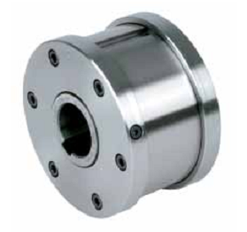
  Применение:
  AL P12-F7D7 | ALP15-F7D7 | ALP20-F7D7 | ALP25-F7D7 | ALP30-F7D7 | ALP35-F7D7 | ALP40-F7D7
  ALP45-F7D7 | ALP50-F7D7 | ALP55-F7D7 | ALP60-F7D7 | ALP70-F2D2 | ALP80-F7D7 | ALP90-F7D7
  ALP100-F7D7 | ALP120-F7D7 | ALP150-F7D7 | ALP200-F7D7 | ALP250-F7D7
   |  | ALMP25-F7D7 | ALMP30-F7D7 | ALMP35-F7D7

STIEBER AL-KEED2
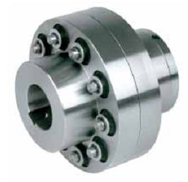
  Применение:
  AL12-KEED2 | AL15-KEED2 | AL20-KEED2 | AL25-KEED2 | AL30-KEED2 | AL35-KEED2 | AL40-KEED2
  AL45-KEED2 | AL50-KEED2 | AL55-KEED2 | AL60-KEED2 | AL70-KEED2 | AL80-KEED2 | AL90-KEED2
  AL100-KEED2 | AL120-KEED2 | AL150-KEED2 | AL200-KEED2 | AL250-KEED2
   |  | ALM25-KEED2 | ALM30-KEED2 | ALM35-KEED2

STIEBER GFR / STIEBER GFRN
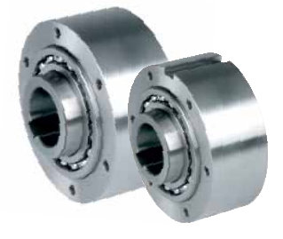
  Применение:
  GFR12 | GFR15 | GFR20 | GFR25 | GFR30 | GFR35 | GFR40 | GFR45 | GFR50
  GFR55 | GFR60 | GFR70 | GFR80 | GFR90 | GFR100 | GFR130 | GFR150
  GFRN12 | GFRN15 | GFRN20 | GFRN25 | GFRN30 | GFRN35 | GFRN40 | GFRN45 | GFRN50
  GFRN55 | GFRN60 | GFRN70 | GFRN80 | GFRN90 | GFRN100 | GFRN130 | GFRN150

STIEBER AL..KMSD2 / ALM..KMSD2
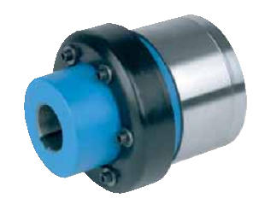
  Применение:
  AL12-KMSD2 | AL15-KMSD2 | AL20-KMSD2 | AL25-KMSD2 | AL30-KMSD2 | AL35-KMSD2 | AL40-KMSD2
  AL45-KMSD2 | AL50-KMSD2 | AL55-KMSD2 | AL60-KMSD2 | AL70-KMSD2 | AL80-KMSD2 | AL90-KMSD2
  AL100-KMSD2 | AL120-KMSD2 | AL150-KMSD2 | AL200-KMSD2 | AL250-KMSD2
   |  | ALM25-KMSD2 | ALM30-KMSD2 | ALM35-KMSD2

STIEBER GFR..F2F3 / GFR..F3F4
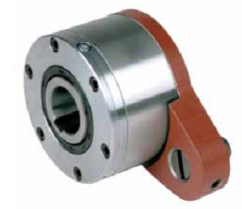
  Применение:
  GFR12-F2F3 | GFR15-F2F3 | GFR20-F2F3 | GFR25-F2F3 | GFR30-F2F3 | GFR35-F2F3
  GFR40-F2F3 | GFR45-F2F3 | GFR50-F2F3 | GFR55-F2F3 | GFR60-F2F3 | GFR70-F2F3
  GFR80-F2F3 | GFR90-F2F3 | GFR100-F2F3 | GFR130-F2F3 | GFR150-F2F3
  GFR12-F3F4 | GFR15-F3F4 | GFR20-F3F4 | GFR25-F3F4 | GFR30-F3F4 | GFR35-F3F4
  GFR40-F3F4 | GFR45-F3F4 | GFR50-F3F4 | GFR55-F3F4 | GFR60-F3F4 | GFR70-F3F4
  GFR80-F3F4 | GFR90-F3F4 | GFR100-F3F4 | GFR130-F3F4 | GFR150-F3F4

STIEBER GFR..F1F2 / GFR..F2F7 / STIEBER GFRN..F5F6
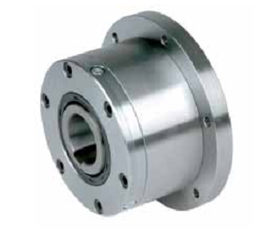
  Применение:
  GFR12-F1F2 | GFR15-F1F2 | GFR20-F1F2 | GFR25-F1F2 | GFR30-F1F2 | GFR35-F1F2
  GFR40-F1F2 | GFR45-F1F2 | GFR50-F1F2 | GFR55-F1F2 | GFR60-F1F2 | GFR70-F1F2
  GFR80-F1F2 | GFR90-F1F2 | GFR100-F1F2 | GFR130-F1F2 | GFR150-F1F2
  GFR12-F2F7 | GFR15-F2F7 | GFR20-F2F7 | GFR25-F2F7 | GFR30-F2F7 | GFR35-F2F7
  GFR40-F2F7 | GFR45-F2F7 | GFR50-F2F7 | GFR55-F2F7 | GFR60-F2F7 | GFR70-F2F7
  GFR80-F2F7 | GFR90-F2F7 | GFR100-F2F7 | GFR130-F2F7 | GFR150-F2F7
  GFRN12-F5F6 | GFRN15-F5F6 | GFRN20-F5F6 | GFRN25-F5F6 | GFRN30-F5F6 | GFRN35-F5F6
  GFRN40-F5F6 | GFRN45-F5F6 | GFRN50-F5F6 | GFRN55-F5F6 | GFRN60-F5F6 | GFRN70-F5F6
  GFRN80-F5F6 | GFRN90-F5F6 | GFRN100-F5F6 | GFRN130-F5F6 | GFRN150-F5F6

STIEBER SMZ
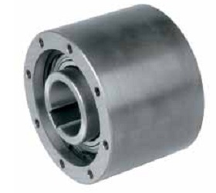
  Применение:
  SMZ20 | SMZ30 | SMZ40 | SMZ50 | SMZ60 | SMZ70

STIEBER FSO / STIEBER FSO-GR / STIEBER HPI
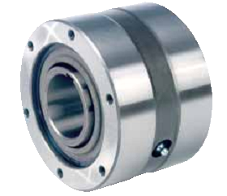
  Применение:
  FSO300 | FSO400 | FSO500 | FSO600 | FSO700
  FSO300 GR | FSO400 GR | FSO500 GR | FSO600 GR | FSO700 GR
  HPI300 | HPI300 | HPI300 | HPI300 | HPI300

STIEBER FSO / STIEBER FS / STIEBER HPI
Применение:
FSO750 | FSO800 | FSO900 | FSO1027
FS750 | FS800 | FS900 | FS1027
HPI750 | HPI800 | HPI900 | HPI1027

STIEBER ALG
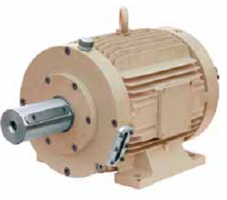
  Применение:
  AL30-G1 | AL40-G2 | AL50-G3 | AL60-G3 | AL70-G3
  AL80-G4 | AL90-G4 | AL100-G4 | AL120-G5 | AL150-G5

STIEBER RSCI
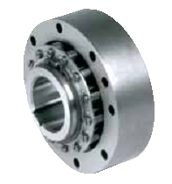
  Применение:
  RSCI20 | RSCI25 | RSCI30 | RSCI35 | RSCI40 | RSCI45 | RSCI50
  RSCI60 | RSCI70 | RSCI80 | RSCI90 | RSCI100 | RSCI130

STIEBER RSCI
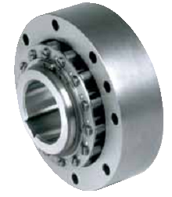
  Применение:
  RSCI180 | RSCI180M | RSCI180 II | RSCI180 II-M | RSC220 | RSC220M | RSCI220 II
  RSCI220 II-M | RSCI240 | RSCI240 M | RSCI240 II | RSCI240 II-M | RSCI260 | RSCI260 M
  RSCI260 II | RSCI260 II-M | RSCI300 | RSCI300 M | RSCI300 II

STIEBER RIZ / STIEBER RINZ
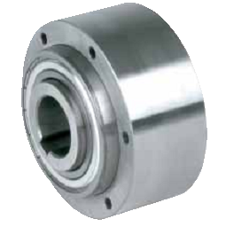
  Применение:
  RIZ30 | RIZ35 | RIZ40 | RIZ45 | RIZ50 | RIZ60 | RIZ70 | RIZ80 | RIZ90 | RIZ100 | RIZ130
  RINZ30 | RINZ35 | RINZ40 | RINZ45 | RINZ50 | RINZ60 | RINZ70 | RINZ80 | RINZ90 | RINZ100 | RINZ130

ACCESSORIES
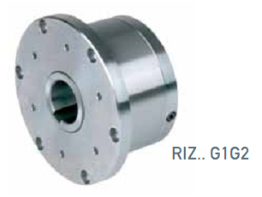
  Применение:
  RIZ30-G1G2 | RIZ35-G1G2 | RIZ40-G1G2 | RIZ45-G1G2 | RIZ50-G1G2 | RIZ60-G1G2
  RIZ70-G1G2 | RIZ80-G1G2 | RIZ90-G1G2 | RIZ100-G1G2 | RIZ130-G1G2
  RIZ30-G2G7 | RIZ35-G2G7 | RIZ40-G2G7 | RIZ45-G2G7 | RIZ50-G2G7 | RIZ60-G2G7
  RIZ70-G2G7 | RIZ80-G2G7 | RIZ90-G2G7 | RIZ100-G2G7 | RIZ130-G2G7
  RIZ30-G5G5 | RIZ35-G5G5 | RIZ40-G5G5 | RIZ45-G5G5 | RIZ50-G5G5 | RIZ60-G5G5
  RIZ70-G5G5 | RIZ80-G5G5 | RIZ90-G5G5 | RIZ100-G5G5 | RIZ130-G5G5

STIEBER RIZ..G2G3 / STIEBER RIZ..G3G4
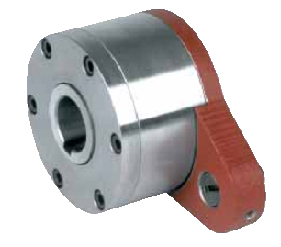
  Применение:
  RIZ30-G2G3 | RIZ35-G2G3 | RIZ40-G2G3 | RIZ45-G2G3 | RIZ50-G2G3 | RIZ60-G2G3
  RIZ70-G2G3 | RIZ80-G2G3 | RIZ90-G2G3 | RIZ100-G2G3 | RIZ130-G2G3
  RIZ30-G3G4 | RIZ35-G3G4 | RIZ40-G3G4 | RIZ45-G3G4 | RIZ50-G3G4 | RIZ60-G3G4
  RIZ70-G3G4 | RIZ80-G3G4 | RIZ90-G3G4 | RIZ100-G3G4 | RIZ130-G3G4

STIEBER RIZ..ELG2
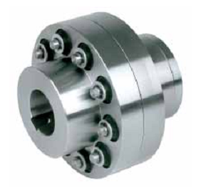
  Применение:
  RIZ30-ELG2 | RIZ35-ELG2 | RIZ40-ELG2 | RIZ45-ELG2 | RIZ50-ELG2 | RIZ60-ELG2
  RIZ70-ELG2 | RIZ80-ELG2 | RIZ90-ELG2 | RIZ100-ELG2 | RIZ130-ELG2

STIEBER RIZ..ESG2
Применение:
RIZ30-ESG2 | RIZ35-ESG2 | RIZ40-ESG2 | RIZ45-ESG2 | RIZ50-ESG2 | RIZ60-ESG2
RIZ70-ESG2 | RIZ80-ESG2 | RIZ90-ESG2 | RIZ100-ESG2 | RIZ130-ESG2

